COMMAND TRANSCEIVER (CTRX)

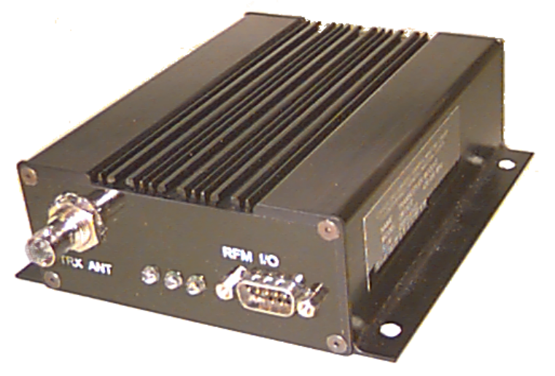

The Command Transceiver Module (CTRX) provides a practical solution for a low cost RF communications link. The CTRX combines the features of both the Command Transmitter and TM Receiver operating in a half-duplex mode. The standard unit is available on a single customer-specified frequency between 430 and 470 MHz for both transmit and receive. As an option, the customer can elect to use different transmit and receive frequencies to increase data throughput. Hardwired data transfer to the CTRX is achieved using a standard RS-232 connection implementing the Request-to-Send (RTS) and Clear-to-Send (CTS) handshaking lines. This implementation allows variable length packets to be transmitted. Prior to transmitting the RF packet, the CTRX adds forward error correction (FEC) and error detection (CRC) information and interleaves the result for burst-error protection. In receive mode, the CTRX performs the reverse function by correcting errors and CRC checking. If uncorrected data errors remain, the packet is discarded ensuring that only valid data is passed.
The Command/TM Transceiver's performance and cost varies with parameters such as carrier frequency, modulation type, maximum output power and data throughput rates.
COMMAND TRANSCEIVER SPECIFICATIONS
Standard unit meets or exceeds the following parameters:
Modulation Type: Narrow band FM (430 - 450 MHz., 450 -470 MHz.)
Spurious Radiation: > 60 dB below Carrier
Harmonic Radiation: > 60 dB below Carrier
Receiver Sensitivity: < 0.35μV for 12dB SINAD
Selectivity: 70 dB
Spurious Rejection: 60 dB
Frequency Stability: +/- 5 ppm
Hardwired data rate: 9600 Baud RS232 8 bits, No Parity, 1 Stop (tailorable)
Data Transfer Rate: 9600 Baud with 12.5 KHz Bandwidth (tailorable)
Input Power (Nominal): 10 to 15 Volts DC
0.15 Amp in Receive mode
1.0 Amp in Transmit mode
Output Power: 2 Watts minimum (5 Watts optional)
Transmit Duty Cycle: 67% (2 Minutes ON, 1 Minute OFF )
Operating Temperature: -30°C to +50°C
Storage Temperature: -55°C to +125°C
Dimensions: 5.38"(136.5cm) x 5.12"(130.2cm) x 1.79"(45.5cm)
Weight: 16 oz. (454g)
Connectors: 9 pin D (Male) for power and data
BNC Jack for RF input/output

- CJV invites requests for requirements other than those stated above.
* Specifications may vary according to particular customer requirements.
** This system will meet or exceed these specifications however operation is not guaranteed outside of these parameters.

